

**Click Through CP Manual and AutomationTEST**

**PREPARED FOR** Netgear

**PREPARED BY**

Candela India Pvt Ltd

# 1. Project Overview

There are total four file which is useful to run Click through captive portal task.

1. portal-bot.pl – This is the main Perl script which is passing to GUI
2. botlib.pm – This is the standard library where define number of methods which is useful for this test
3. bp_net.pm – This is the module which is import from portal-bot.pl file.
4. portal-bot.bash-example – This file use to execute the portal-bot.pl script

**2. How to use Script (Two ways to run test manually)?**

1. **First Method.** 
   1. Copy all the file in /home/lanforge/ directory.
      1. cp filename /home/lanforge/
   2. Create station in lanforge
   3. open “portal-bot.bash-example” & edit station name(-i) and IP address(--ip4) in file and save it

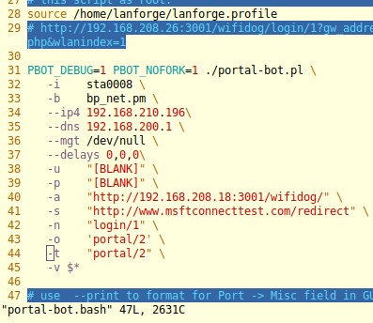

* 1. run the script
     1. ./ portal-bot.bash-example
  2. You can check the event logs for all pass and fail result

1. **Second Method.** 
   1. Copy all the file in /home/lanforge/ directory.
      1. cp filename /home/lanforge/
   2. create stations in lanforge Gui
   3. run this command (./portal-bot.pl –print)
   4. you will get script detail after giving above command
   5. copy this statement
      1. ./portal-bot.pl --logout_url "" --bot "" --ap_url "" --pass "" --start_url "" -login_form "" --login_action "" --user ""
   6. Select all the station ->click on batch Modifier->paste above data on Post IF-UP Script>Apply

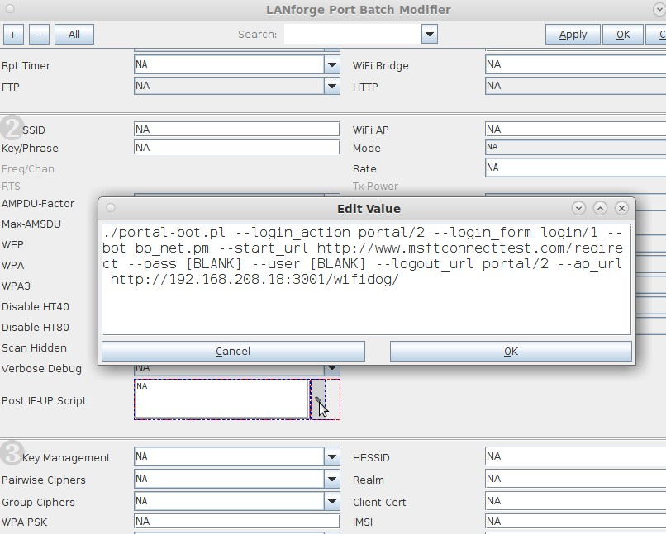

# 3. How to run script

Some examples are

Go to working directory :

cd Candela-Automation/click_through_portal/ and run below test.

1**. Run all scenarios(2.4 GHz, 5 GHz, 2.4 + 5 GHz)** : python3 clickthru_captive_portal.py -mgr 192.168.200.12 -ssid portal -pwd [Blank] -sec open --radio1 wiphy0 --radio2 wiphy1 -num_port 40 --mode1 6 --mode2 10 --ip 192.168.215.49 --all_test 1

2.**Run two scenario(2.4 GHz, 5 GHz)** : python3 clickthru_captive_portal.py -mgr 192.168.200.12 -ssid portal -pwd [Blank] -sec open --radio1 wiphy0 --radio2 wiphy1 -num_port 40 --mode1 6 --mode2 1 --ip 192.168.215.49 --test_2G 1 --test_5G 1

**3. Run one scenario only(2.4 + 5 GHz)** : python3 clickthru_captive_portal.py -mgr 192.168.200.12 -ssid portal -pwd [Blank] -sec open --radio1 wiphy0 --radio2 wiphy1 -num_port 40 --mode1 6 --mode2 10 --ip 192.168.215.49 --test_both 1

optional arguments: -h, --help show this help message and exit

-mgr HOST, --host HOST host name

-ssid SSID, --ssid SSID ssid for client

-pwd PASSWD, --passwd PASSWD password to connect to ssid -sec SECURITY,

--security SECURITY security

-radio1 RADIO1, --radio1 RADIO1 radio at which client will be connected on 2.4GHz

-radio2 RADIO2, --radio2 RADIO2 radio at which client will be connected on 5 GHz

-num_port NUM_PORT, --num_port NUM_PORT number of client

--mode1 MODE1 Used to force mode of stations.(enter 6 for 2.4GHz)

--mode2 MODE2 Used to force mode of stations.(10 for 5GHz)

--ip IP ip address of AP

--user USER --Enter the username

--all_test ALL_TEST --run all scenario

--test_2G TEST_2G --run 2.4 GHz scenario

--test_5G TEST_5G --run 5 GHz scenario

--test_both TEST_BOTH --run 2+5 GHz scenario

# 4. Contact

Visit -<https://www.candelatech.com/>

For any support related help contact - support@candelatech.com